WORKSHOP REGISTRATION PORTAL
@CREATIVITY THINK (9483175986/7019689991)

ABSTRACT:
Workshop Registration Portal is a web application designed to streamline the registration and management of workshops, courses, and training events. Users can browse available workshops, register, make payments, attend sessions, and submit feedback. Administrators manage workshops, track attendees, export analytics reports, and monitor dashboards. The system uses Django and Django Rest Framework for backend services and React with Recharts for frontend dashboards. This platform provides a seamless experience for attendees while giving organizers powerful tools to manage registrations, attendance, and feedback analytics efficiently..

INTRODUCTION OF THE PROJECT:
Organizing workshops and training sessions requires effective registration management, payment tracking, attendance monitoring, and feedback collection. Workshop Registration Portal provides a centralized system where users can browse workshops, register, pay, attend, and submit feedback. Administrators can add or edit workshops, manage attendees, export analytics, and monitor dashboards. The backend leverages Django and Django Rest Framework for secure data handling and business logic, while the frontend uses React and Recharts for interactive dashboards. The platform ensures smooth participant management and comprehensive event analytics..

PROJECT OBJECTIVES:

• Enable users to browse and register for workshops
• Facilitate payment processing for event registration
• Track attendance and participation
• Collect and analyze user feedback
• Allow administrators to manage workshops and attendees
• Provide dashboards and exportable analytics reports
• Improve event organization efficiency

PROBLEM OF THE STATEMENT:
Managing workshop registrations manually can lead to errors in participant tracking, payment collection, attendance monitoring, and feedback analysis. Organizers require a streamlined system to handle multiple workshops efficiently. Workshop Registration Portal addresses these challenges by offering a web-based platform where attendees can register, pay, attend, and submit feedback, while administrators manage workshops, monitor attendance, track payments, and generate analytics reports. This ensures efficient workshop management and enhanced participant experience..

MOTIVATION OF THE PROJECT:
• Streamline registration and payment processes for workshops
• Ensure accurate attendance and participation tracking
• Enable easy feedback collection and analysis
• Provide administrators with analytics dashboards for better decision-making
• Improve overall efficiency of workshop management

BLOCK DAIGRAM OF PROJECT:

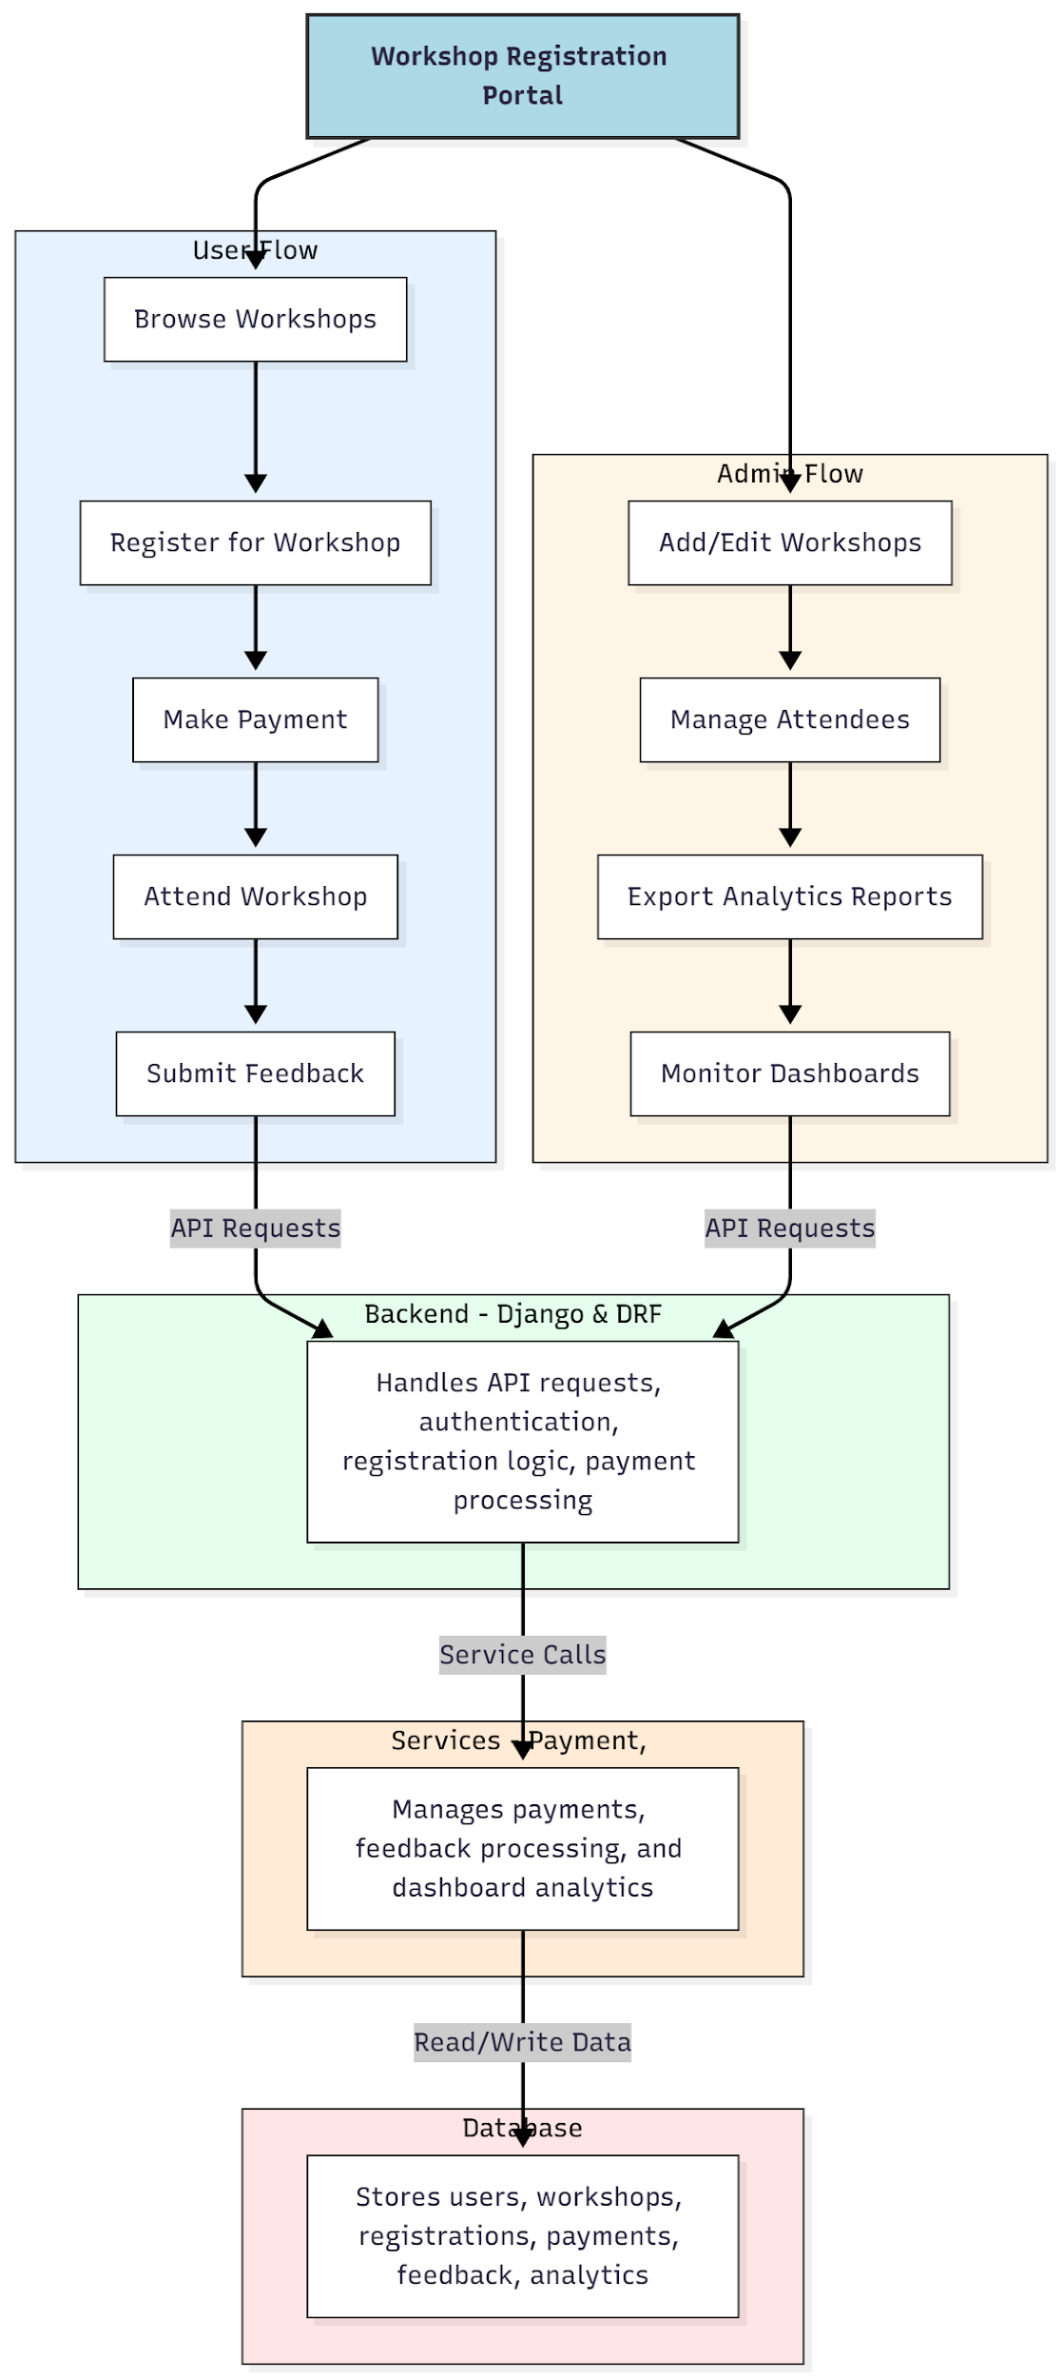

WORKING OF THE PROJECT:
Users browse available workshops, register for desired events, make payments, attend sessions, and submit feedback. The backend manages API requests, authentication, registration workflows, payment processing, and feedback storage. Services handle payment processing, feedback analytics, and dashboard updates. Administrators add or edit workshops, manage attendee lists, export analytics, and monitor dashboards. The system ensures seamless registration, accurate attendance tracking, secure payment handling, and comprehensive event analytics for organizers..

SOFTWARE REQUIREMENT:
- Backend:
  - Python 3.x
  - Django
  - Django REST Framework
  - SQLite/PostgreSQL
- Frontend:
  - Node.js and npm
  - React.js
  - Axios
- Development Tools:
  - Visual Studio Code
  - Postman (for testing APIs)
  - Git/GitHub (for version control)
- Server/Deployment (Optional):
  - Gunicorn, Nginx, or Heroku/AWS for hosting

ADVANTAGES OF THE PROJECT:

• Streamlined workshop registration and payment
• Accurate attendance tracking
• Easy collection and analysis of feedback
• Exportable analytics and dashboards for administrators
• Improved management of multiple workshops
• Secure handling of registrations and payments
• Enhanced participant experience
• Centralized platform for organizers

APPLICATIONS OF THE PROJECT:
• Conferences and seminar registrations
• Educational workshop management
• Training program scheduling and monitoring
• Feedback collection and analysis for workshops
• Payment tracking for event registrations
• Administrative dashboards for event organizers
• Exportable reports for attendees and organizers
• Centralized registration management for institutions

REFERENCES:

- Django REST Framework Documentation — Django Software Foundation. Django Documentation. Available: https://docs.djangoproject.com/
- Django REST Framework. DRF Documentation. Available: https://www.django-rest-framework.org/
- React. React Official Documentation. Available: https://reactjs.org/docs/getting-started.html
- Redux. Redux Documentation. Available: https://redux.js.org/introduction/getting-started
- PostgreSQL Global Development Group. PostgreSQL Documentation. Available: https://www.postgresql.org/docs/
- MySQL. MySQL Reference Manual. Available: https://dev.mysql.com/doc/
- Git. Git Documentation. Available: https://git-scm.com/doc
- Node.js. Node.js Documentation. Available: https://nodejs.org/en/docs/
- Axios. Axios Documentation. Available: https://axios-http.com/docs/intro
- Socket.io Documentation – https://socket.io/docs/

